**INTERNAL TRANSPORT CIRCULATORY SYSTEM**

**Question 1**

Which of the following correctly describes most arteries?

|  |  |  |  |  |
| --- | --- | --- | --- | --- |
|  | **Thickness of muscle** | **Valves present** | **Oxygenation of blood** | **Pressure** |
| a. | Thick | Yes | Oxygenated | High |
| b. | Thin | Yes | Deoxygenated | Low |
| c. | Thick | No | Oxygenated | High |
| d. | Thin | No | Oxygenated | High |

**Question 2**

Carbon dioxide transport in the blood occurs mainly by

1. the platelets.
2. the erythrocytes.
3. forming hydrogen carbonate / bicarbonate ions.
4. the plasma.

**Question 3**

On the following diagram of the heart, where would you expect to find the sino-atrial node?



1. A
2. B
3. C
4. D

**Question 4**

Which of the following correctly describes the flow of blood through the heart?

1. Bicuspid valve ⭢ right ventricle ⭢semilunar valve ⭢pulmonary artery
2. Tricuspid valve ⭢left ventricle ⭢semilunar valve ⭢pulmonary artery
3. Bicuspid valve ⭢ left ventricle ⭢semilunar valve ⭢aorta
4. Tricuspid valve ⭢right ventricle ⭢semilunar valve ⭢aorta

**Question 5**

Ventricular contraction causes the opening of the

* 1. atrioventricular valves.
  2. semilunar valves.
  3. bicuspid valve.
  4. atrioventricular and semilunar valves.

**Question 6**

Approximately **45%** of blood by volume is comprised of

* 1. Platelets.
  2. Erythrocytes.
  3. Plasma.
  4. Leukocytes.

**Question 7**

Blood travels from the

1. left atrium to the aorta.
2. left ventricle to the vena cava.
3. right ventricle to the pulmonary artery.
4. right atrium to the pulmonary vein.

**Question 8**

The following arteries originate from the aorta. Identify the most **SUPERIOR** artery.

1. Hepatic artery.
2. Femoral artery.
3. Renal artery.
4. Carotid artery.

**Question 9**

During a typical cardiac cycle of 0.8 seconds, the ventricles spend how much time in diastole?

1. 0.2 seconds
2. 0.3 seconds
3. 0.4 seconds
4. 0.5 seconds

**QUESTION 10** (Total 11 marks)

The diagram below shows the passage of red blood cells through a capillary in muscle tissue. Use this diagram to answer questions (a) and (b).

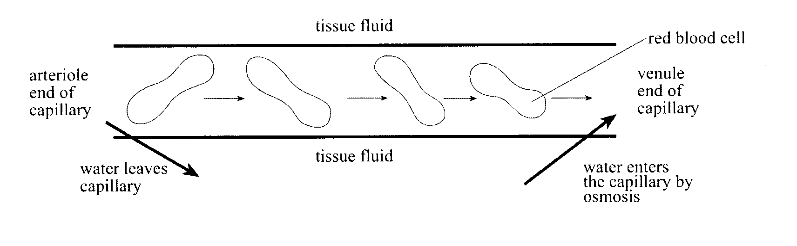

1. Explain why water enters the capillary at the venule end by osmosis. (4)

____________________________________________________________________________________________________________________________________________________________________________________________________________________________________________________________________________________________________

1. Describe **TWO** ways in which the composition of the blood at the arteriole end of the capillary differs from the composition of the blood at the venule end of the capillary. (4)

________________________________________________________________________________________________________________________________________________________________________________________________________________________________________________________________________________________

1. Describe **THREE** differences between arteries and veins. (3)

__________________________________________________________________________________________________________________________________________________________________________________________________________________

**QUESTION 11** (Total 7 marks)

Complete each sentence with the missing word(s). Each **CORRECT** sentence is worth one mark.

1. The heart is enclosed in a membrane called the ____________________________.
2. The heart wall is made up of ___________________________ muscle.
3. The superior chambers in the heart are called _____________________ with the left chamber receiving blood from the _______________________ via the pulmonary veins.
4. The wall separating the right and left side of the heart is called the _____________________.
5. When the heart contracts or pumps this is termed_________________________________.
6. Blood leaves the heart via the _________________________ or ____________ _____________.
7. Deoxygenated blood flows from the right ventricle to the ___________________________ via the ______________ _________________.

**Question 12**

1. Humans have a specialised internal transport system linking the major organs to the cells and tissues of the body. Discuss the role of the heart, arteries and veins in this transport system. What is blood pressure and how does this change in the circulatory system? (10)
2. Blood is composed of plasma and a non-liquid part called the formed elements. Describe these two parts of blood. Include in your answer the composition and function of each part. (12)
3. Humans possess a ***double circulatory system***. Describe this system and explain its advantages (12)